**School of Digital Media & Infocomm Technology (DMIT)**

**ST2111 Mobile Application Development I**

**Practical 2**

**Data Types and Operators**

|  |
| --- |
| Objectives:  After completing this lab, you should be able to:   * Write programs which use data types * Write programs which use arithmetic operators |

**Exercise 1: Arithmetic Operators**

1. Create a copy of the **practical1-1** in the same **MAD1** folder.
2. Rename the copied folder as **practical2-1** folder.
3. Write a program in **script.js** that converts Fahrenheit to Celsius. The formula for the conversion is as follows:

**Celsius = 5/9 * (Fahrenheit - 32)**

Your program reads a Fahrenheit degree from the user, then converts it to Celsius and displays the result in an alert. You can use **parseFloat** to convert the input to a number.

var num1 = parseFloat( prompt("Enter the temperature ", "");

Here are steps involved:

1. Prompt the user to enter the temperature in Fahrenheit.
2. Compute and display the temperature in Celsius.

ANSWER: Source Code

|  |  |
| --- | --- |
| HTML | <!DOCTYPE html>  <html>  <head>  <meta charset=*"ISO-8859-1"*>  <script type=*"text/javascript"* src=*"EX_1.js"*></script>  <title>EX 1</title>  </head>  <body>  <p>This is a simple program</p>  <script type=*"text/javasscript"*>  alert()  </script>  </body>  </html> |
| J.S | /**  *  */  /*  Name: EX_1  Purpose: Temperature converter  */  //prompt for fahrenheit  **var** F = parseFloat( prompt("Enter a fahrenheit", ""));  //asking for N  **var** C;  alert(C=5/9*(F-32));  document.write(C) |

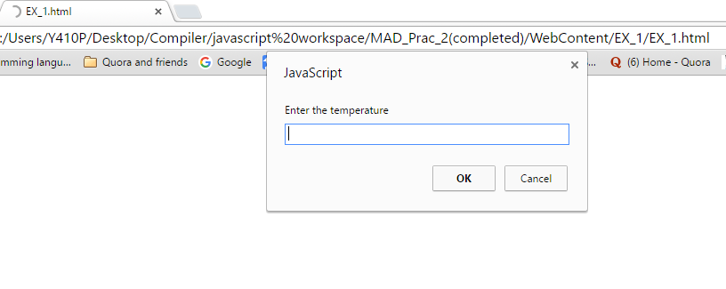

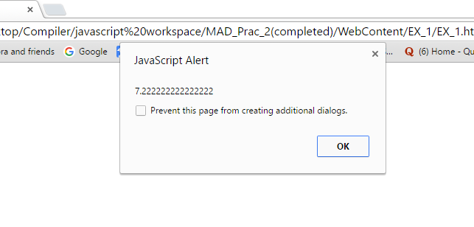

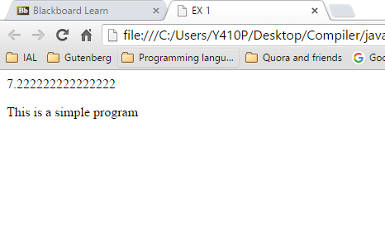

**Exercise 2:**

1. Create a copy of the **practical1-1** in the same **MAD1** folder.
2. Rename the copied folder as **practical2-2** folder.
3. Write a JavaScript program to prompt user to enter two integer values ***m*** and ***n***. The program will compute the sum of all the integers starting from ***m*** to ***n***. For example if the value of ***m*** and ***n*** is ***5*** and ***9*** respectively, then the complete output of the program will be:

|  |
| --- |
| The sum of all the integers from 5 to 9 is 35 |

You are to use only arithmetic operators for the solution, assume the value of variable ***m*** will be smaller of equals to ***n***.

The formula for summation of numbers is:

35c338e3f4e722be72f1304d06655ba6

ANSWER: Source Code(Don’t ask, seemed like a good idea at the time)

|  |  |
| --- | --- |
| HTML | <!DOCTYPE html>  <html>  <head>  <meta charset=*"ISO-8859-1"*>  <script type=*"text/javascript"* src=*"EX_2.js"*></script>  <title>EX 2</title>  </head>  <body>  <p>This is a simple program</p>  <script>  document.write(((N-M+1)*(N+M))/2);  </script>  </body>  </html> |
| J.S | /**  *  */  /*  Name: EX_2  Purpose: calculate sum of all integers  */  //asking for M  **var** M = parseFloat( prompt("Enter a number", ""));  //asking for N  **var** N = parseFloat( prompt("Enter another number", ""));  //Calculating the sum of all integers  **var** A;  alert(((N-M+1)*(N+M))/2); |

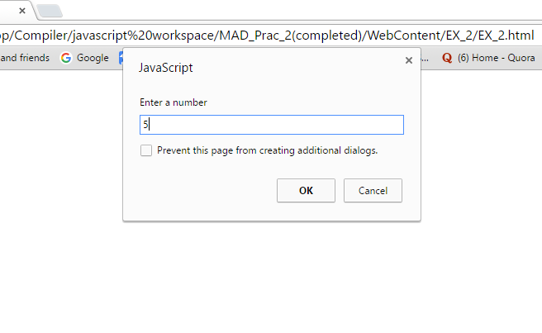

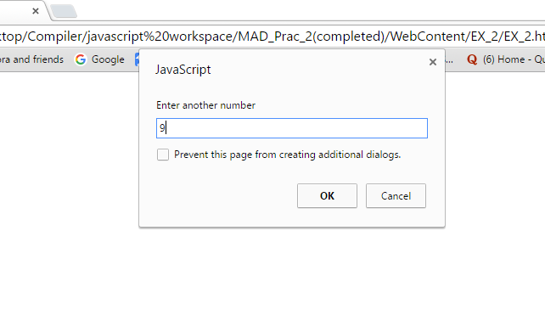

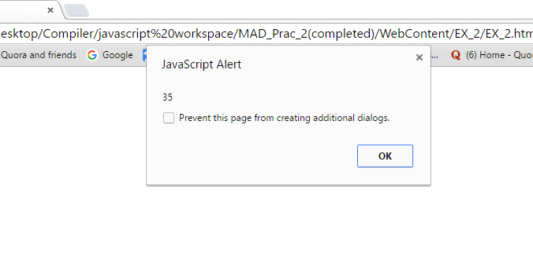

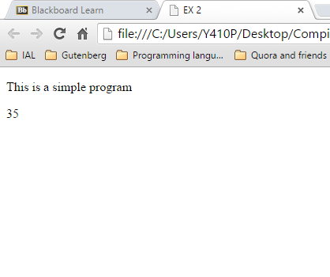

**Exercise 3: Data Types and Operators**

1. Create a copy of the **practical1-1** in the same **MAD1** folder.
2. Rename the copied folder as **practical2-3** folder.
3. Write a program that will display the output of the following expressions**:**

"5" + "3";

"5" - 3;

"5" + 3;

2 + "7"

5 + 9 + "1"

typeof(55)

typeof(true)

typeof("hello there")

ANSWER: Source Code

|  |  |
| --- | --- |
| HTML | <!DOCTYPE html>  <html>  <head>  <meta charset=*"ISO-8859-1"*>  <script type=*"text/javascript"* src=*"EX_3.js"*></script>  <title>EX 3</title>  </head>  <body>  <p>This is a simple program</p>  </body>  </html> |
| J.S | /*  Name: EX_3  Purpose: do stuff to see what happens  */  **var** A  alert("5" + "3");  alert("5" - 3);  alert("5" + 3);  alert(2 + "7");  alert(5 + 9 + "1");  alert(**typeof**(55));  alert(**typeof**(**true**));  alert("hello there")  document.write("5" + "3" + "<br>");  document.write("5" - 3 + "<br>");  document.write("5" + 3 + "<br>");  document.write(2 + "7" + "<br>");  document.write(5 + 9 + "1" + "<br>");  document.write(**typeof**(55) + "<br>");  document.write(**typeof**(**true**) + "<br>");  document.write("hello there" + "<br>"); |

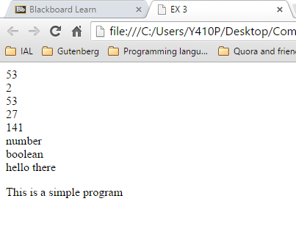

**Exercise 4: Arithmetic Operators**

1. Create a copy of the **practical1-1** in the same **MAD1** folder.
2. Rename the copied folder as **practical2-4** folder.
3. Given that x=100 and y=2, write a program that displays the result of each of the following arithmetic operators. Fill the table below with the results from the program:

|  |  |
| --- | --- |
| Expression | Result |
| ++x | 101 |
| y-- | 1 |
| x += y; | 102 |
| x=x+y; | 102 |
| x -= y; | 98 |
| x *= y; | 200 |
| x = x * y; | 200 |
| x /= y; | 50 |
| x = x / y; | 50 |
| x %= y; | 0 |

For example:

var x=100;

var y=2;

x+=y;

alert(x);

ANSWER: Source Code

|  |  |
| --- | --- |
| HTML | <!DOCTYPE html>  <html>  <head>  <meta charset=*"ISO-8859-1"*>  <script type=*"text/javascript"* src=*"EX_4.js"*></script>  <title>EX 4</title>  </head>  <body>  <p>This is a simple program</p>  </body>  </html> |
| J.S | /**  *  */  /*  Name: EX_4  Purpose: Do stuff and see what happens(Arithmetic)  */  **var** X=100;  **var** Y=2;  //Prefix Increment  alert(++X);  document.write(X + "<br>");  **var** X=100;  **var** Y=2;  //Prefix decrement  alert(Y--);  document.write(Y + "<br>");  **var** X=100;  **var** Y=2;  //addition  alert(X+=Y);  document.write(X + "<br>");  **var** X=100;  **var** Y=2;  alert(X=X+Y);  document.write(X + "<br>");  **var** X=100;  **var** Y=2;  alert(X-=+Y);  document.write(X + "<br>");  **var** X=100;  **var** Y=2;  alert(X*=Y);  document.write(X + "<br>");  **var** X=100;  **var** Y=2;  alert(X=X*Y);  document.write(X + "<br>");  **var** X=100;  **var** Y=2;  alert(X/=Y);  document.write(X + "<br>");  **var** X=100;  **var** Y=2;  alert(X=X/Y);  document.write(X + "<br>");  **var** X=100;  **var** Y=2;  alert(X%=Y);  document.write(X + "<br>"); |

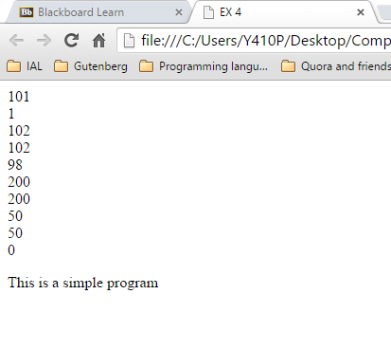

**Exercise 5: Comparison Operators**

1. Create a copy of the **practical1-1** in the same **MAD1** folder
2. Rename the copied folder as **practical2-5** folder
3. Given that **var1 = 3** and **var2 = 4** write a program that displays the result of each of the following comparison operators. Fill the table below with the results from the program:

|  |  |
| --- | --- |
| Expression | Result |
| 3 == var1 | True |
| "3" == var1 | True |
| 3 == '3' | True |
| var1 != 4 | True |
| var2 != "3" | True |
| 3 === var1 | True |
| 3 !== '3' | True |
| "12" > 2 | True |
| var1 <= var2 | True |
| var2 > var1 | True |

ANSWER: Source Code

|  |  |
| --- | --- |
| HTML | <!DOCTYPE html>  <html>  <head>  <meta charset=*"ISO-8859-1"*>  <script type=*"text/javascript"* src=*"EX_5.js"*></script>  <title>EX 5</title>  </head>  <body>  <p>This is a simple program</p>  </body>  </html> |
| J.S | /**  *  */  /*  Name: EX_5  Purpose: Do stuff to see what happens(comparison)  */  var1 = 3;  var2 = 4;  alert(3 == var1);  document.write(3 == var1);  document.write("<br>");  var1 = 3;  var2 = 4;  alert("3" == var1);  document.write("3" == var1);  document.write("<br>");  var1 = 3;  var2 = 4;  alert(3 == '3');  document.write(3 == '3');  document.write("<br>");  var1 = 3;  var2 = 4;  alert(var1 != 4);  document.write(var1 != 4);  document.write("<br>");  var1 = 3;  var2 = 4;  alert(var2 != "3");  document.write(var2 != "3");  document.write("<br>");  var1 = 3;  var2 = 4;  alert(3 === var1);  document.write(3 === var1);  document.write("<br>");  var1 = 3;  var2 = 4;  alert(3 !== '3');  document.write(3 !== '3');  document.write("<br>");  var1 = 3;  var2 = 4;  alert("12" > 2);  document.write("12" > 2);  document.write("<br>");  var1 = 3;  var2 = 4;  alert(var1 <= var2);  document.write(var1 <= var2);  document.write("<br>");  var1 = 3;  var2 = 4;  alert(var2 > var1);  document.write(var2 > var1);  document.write("<br>"); |

